**ONLINE SHOPPING SYSTEM**

The Online Shopping system (OSS) application enables vendors

to set up online shops, customers to browse through the shops, and a

system administrator to approve and reject requests for new shops

and maintain lists of shop categories. Also the developer is designing

an online shopping site to manage the items in the shop and also

help customers to purchase them online without visiting the shop

physically.The online shopping system will use the internet as the sole

method for selling goods to its consumers.

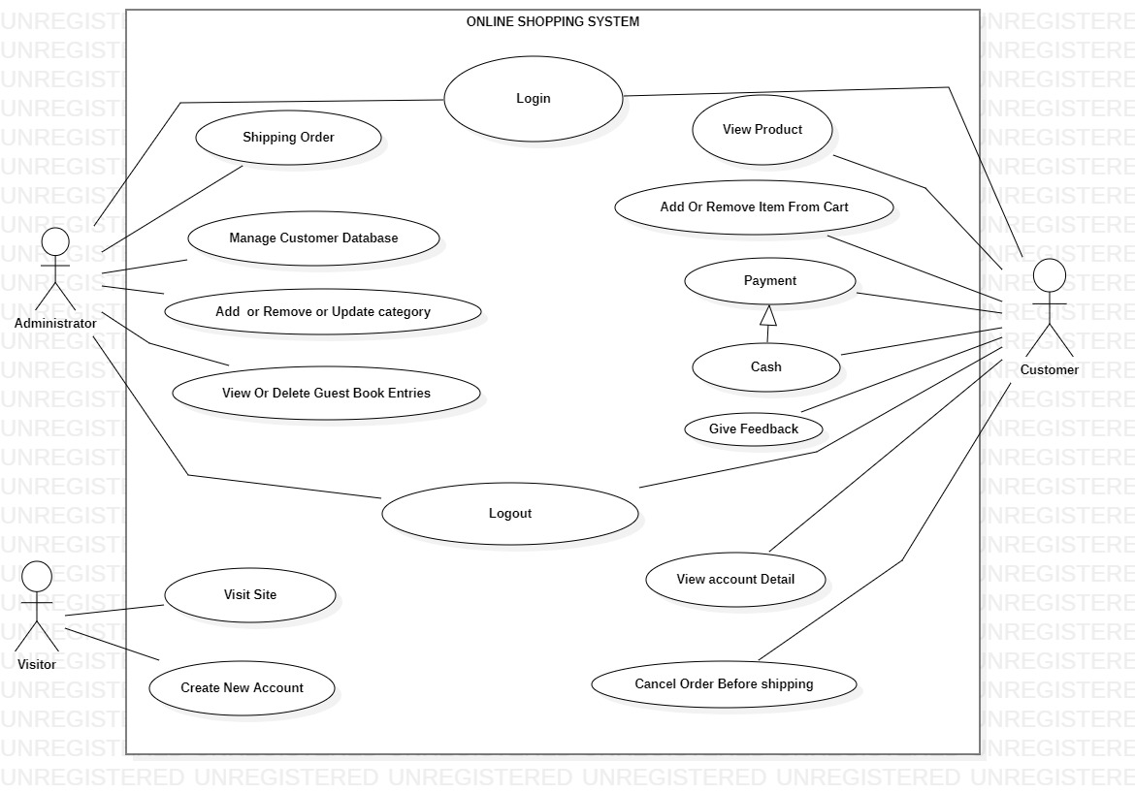

The Process Involved Are:

\***System:** Online Shopping System

\***Actors:**

1.Administrator

2.Visitor

3.Customer

\***Use Case:**

**\*Customer:**

\***Login:**

Customer logins to the system by entering

valid user id and password for the

shopping.

\***View product:**

Customer can view the products and add them to the cart for purchasing.

* **Changes to Cart:** Changes to cart means the customer after login or registration can make order or cancel order of the product from the shopping cart.

**\* Payment:**

In this system we are dealing the mode of payment

by Cash. We will extend this to credit card, debit card etc in the future.

\***Give Feedback:**

Customer can give feedback related to products or system.

**\*Logout:**

After ordering or surfing for

the product customer has to

logout.

**\*View Account Detail:**

Customer has access to view their account details such as items in cart ,payment ,bought items,etc.

**\*Cancel Order Before Shipping:**

If customer is not satisfied with the order placed,it can be cancelled before shipping.

\***Administrator:**

1.Shipping order

2.Manage customer database

3.Add /remove/update category

4.View /delete guest book entries

**\*Visitor:**

1.Visit site

2.Create new account

**Relationships:**

**1.Association:** For communication and interaction.

**2.Generalization:** Generalization is used when you find two or more use cases that have commonalities in behavior, structure, and purpose.

**THANK YOU**